**CONTROL STRUCTURES :**

**If statement:**

If statement is a conditional statement that allows you to execute a block of code based on whether a specified condition is true or false.

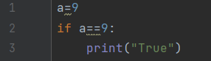

**Output:**



**If – else:**

If-else executes code block if condition is true (if), or another block if false (else).

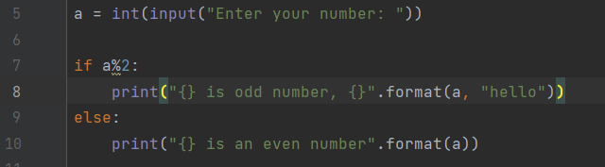

**Output:**



**If – elif – else:**

Elif also checks a condition.

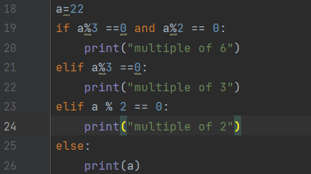

**Output:**



**Nested if:**

If there is a if inside a if then its a nested if statement.

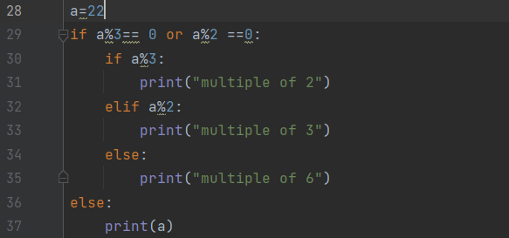

**Output:**



**For loop:**

For looprepeats a block of code for each item in a sequence or range.

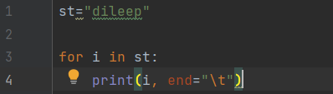

**Output:**



**While:**

While looprepeats a block of code for each item in a sequence or range.

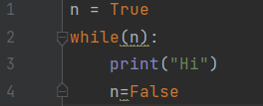

**Output:**



**Nested loop:**

Loop inside a loop is a nested loop.

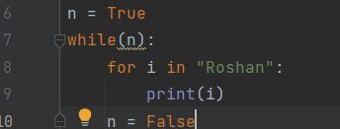

**Output:**

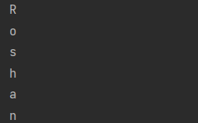

**Break, pass and continue:**

* break: Exits the loop prematurely.
* pass: Placeholder for an empty block.
* continue: Skips the rest of the loop, moving to the next iteration.

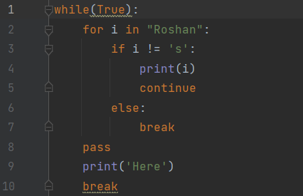

**Output:**

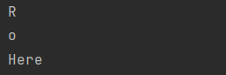

**Input and Output:**

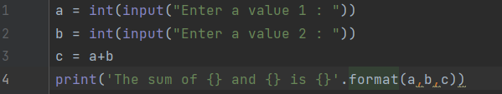

**Output:**

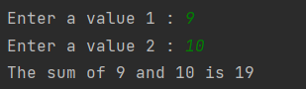

**Lists:**

Ordered collection. Mutable. Stores various data types. Accessed by index. Common operations: append, remove, slice

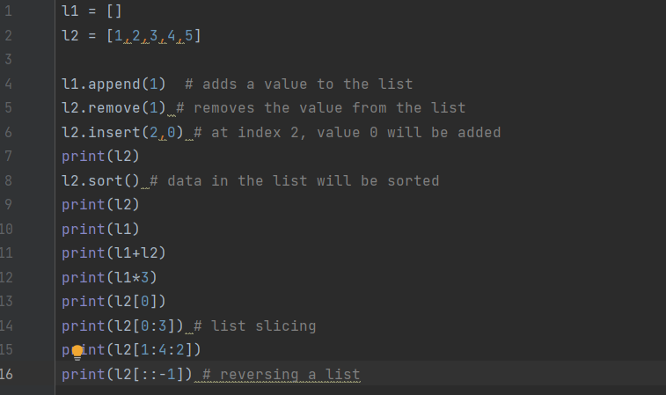

**Output:**

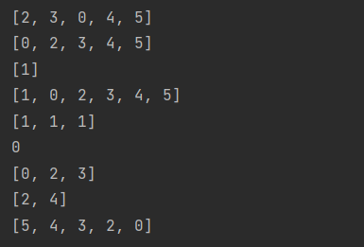

**Dictionaries:**

Unordered key-value pairs. Mutable. Efficient for lookups. Keys must be unique.

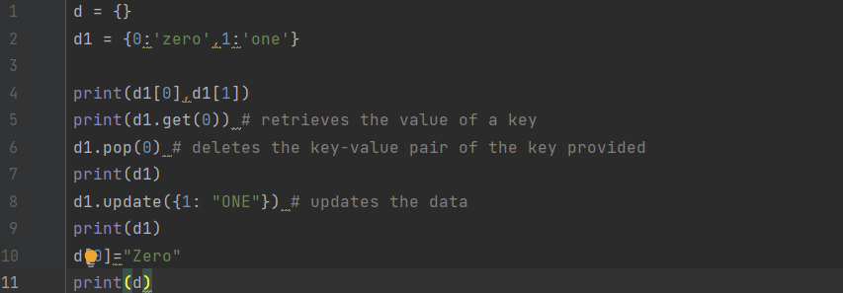

**Output:**

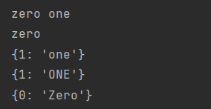

**Sets:**

Unordered collection. Mutable. No duplicate elements. Common operations: add, remove, union, intersection.

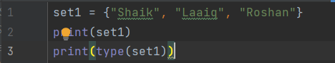

**Output:**



**Maps:**

In Python, "maps" are commonly referred to as dictionaries. They consist of key-value pairs for efficient data retrieval and storage.

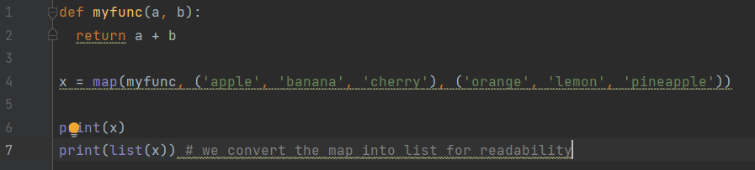

**Output:**

